1. **Summary**

The objective of the project is to improve the tactical allocation system currently in place by adding more signals such as relative momentum, VIX and Variance Risk Premium.

Currently, the HOD Group uses a quantitatively based strategic asset allocation process, which attempts at overcoming the common pitfalls of mean-variance algorithms. They also employ a tactical overlay based on a combined signal which aims at identifying periods of market stress with two methods of conditioning expectations based on changes in return (momentum signals) and risk (disruption signals) on majority of 10 index funds: U.S. equities, International equities, Emerging market equities, Low beta equities, Corporate bonds, European government bonds, commodities, real estate investment trusts, hedge funds, and cash.

During the course of this project, we have researched on the ideas for signals provided to us by HOD group (Relative momentum, VIX and Variance Risk Premium). We planned to add relative momentum to all the major index funds (excl. low beta and hedge funds) and VRP for only U.S. equities. Relative momentum is applied across equities, bonds and commodities. Till date, we have successfully added relative momentum signal and back-tested them. Going forward, we plan to do the same on VRP signal.

1. **Literature Review**

Currently, HOD group uses absolute momentum, simple moving average and the absorption ratio in their existing portfolio to avoid periods of market stress. The absorption ratio signal is designed to invest more into cash when the systematic risk of the asset class is high and more in the asset class when the systematic risk of the asset class is low (Kritzman, Li, Page and Rigobon, 2010). The simple moving average signal invests more in an asset class when the price is above the 12 month moving average and less when it is below the 12 month moving average (Gray, 2015). The absolute momentum signal invests in an asset class when the asset class’s past return is above the risk-free rate and less in the asset class when its past return is less than the risk-free rate. By doing so, this signal is able to reduce the volatility and downside of the portfolio (Antonacci. 2013a). While both signals have proven to be successful at avoiding periods of market stress and, in turn, producing higher risk-adjusted return, current literature suggests that they can be improved upon by potentially adding a relative momentum, VIX and variance risk premium signal.

A cross-sectional momentum signal takes long positions in assets that have high past returns and short positions in assets that have low past returns relative to all assets and is believed to be caused by anchoring, herding, the disposition effect, risk management schemes and confirmation bias (Antonacci, 2013b). While relative momentum is more well-known than absolute momentum, it only seems to help increase the return and does not appear to reduce volatility or drawdown for equities. Relative momentum, unlike absolute momentum, does not allow for diversification on the individual asset level because it allows for individual assets to enter, exit and potentially re-enter the portfolio through time (Antonacci, 2013a). However, there is evidence to suggest that relative momentum does reduce the volatility and increase the returns of the portfolio when applied across asset classes (Antonacci, 2011). Combining cross-sectional momentum and absolute momentum to form a dual momentum portfolio leads to higher returns and lower risk than portfolios that only incorporate absolute momentum or cross-sectional momentum (Antonacci, 2013b). The dual momentum portfolio also appears to have stochastic dominance over the relative and absolute momentum portfolios (Antonacci, 2013b). Applying cross-sectional momentum on a more general level works just as well as applying the signal on an individual asset level (Antonacci, 2015). In addition to this, there is evidence that momentum works much better when applied to high value stocks and does not work well during high volatility periods since volatility has a significant positive relationship with mean reversion.

Most of the literature on VIX signals suggests that there is a significant positive relationship between the VIX or current implied volatility and future returns and that it can be exploited through technical trading signals such as filter rule tests, moving average crossover rules and trading range breakout rules (Kozyra and Lento). There is also evidence to suggest that the VIX signal is a good predictor of future volatility (Whaley, 2008). However, there is also some research to suggest that while high VIX levels leads to higher market returns, it also leads to lower risk-adjusted returns (Orford, Econompic Article). The Sharpe ratio of the S&P 500 is higher when the VIX is low than when the VIX is high (Orford, Econompic Article). During the project, we will, thus, have to figure out a way to determine which method give the current strategy the best risk-adjusted return.

The variance risk premium is the difference between the market implied variance and the expected realized variance. Since the variance is very persistent, the current realized variance or the forecasted realized variance from a GARCH model can be used as a proxy for the expected realized variance. According to the theories behind risk aversion and efficient markets, higher expected return comes from higher risk. In this case, the risk comes in the form of the variance risk premium. When the variance risk premium, investors expect an unusually high future level of volatility in the market and, thus want to be rewarded with extra returns for their investments (Deutsche Bank Global Markets Research, September, 2011). Research suggests that a model-free implied volatility measure works best when predicting future returns from the variance risk premium and that the variance risk premium is negatively related to future GDP growth (Bollerslev, Tauchen and Zhou, 2009).

Thinking intuitively, when the variance risk premium signals a high degree of risk aversion throughout the economy, agents tend to cut their investment expenditures and shift their portfolios to less risky investments. This, in turn, increases the expected future returns. We can thus use this information to predict the booms and bursts associated with the changes in the market implied risk aversion.

The regression equation is: $R_{eit}=α_{i}+β_{i}x Factor_{t}+u_{it}$

$$Re<-excess return on the twenty five fama french size and book to market sorted portfolios \\ Factor_{t}<-Variance risk premium$$

While there is evidence to suggest that there is a positive relationship between the variance risk premium and future market returns, there is no evidence to show that investing in the market when the variance risk premium is high leads to higher future Sharpe ratios for the portfolio. There is also conflicting research that points out that while the variance risk premium with intraday data works best in the United States, it works best with monthly data in other countries (Bollerslev, Marrone, Xu, Zhou, 2014). There is also evidence to suggest that open, close, high and low prices can be used to construct better estimators of variance than the variances estimated using closing prices (Yang and Zhang, 2000).

The findings of this literature review thus presents us with several conundrums that we will have to deal with throughout the course of this project. Two of them are how to implement to variance risk premium and VIX signal in tandem and how to utilize the information from the VIX and variance risk premium to generate the highest return from the portfolio by making it more capable of avoiding periods of market stress. From our research, it seems like there may be a high correlation between the variance risk premium and VIX signal and that while both high variance risk premium and VIX levels lead to high future returns, it might hinder the overall portfolio’s goal of generating profits from avoiding periods of market stress.

1. **Data Description**

The time series of returns and relative weights for a pre-existing strategic asset allocation framework serve as the starting point for our analysis. Investable assets within that framework are trade-able net return indices. Data was provided by the HOD Group.

**Table 1: HOD Group Investable assets**



* 1. **Data used to implement relative momentum signal**

Relative momentum trigger relies on daily returns from all the indices mentioned in table 1 except low beta equities and hedge funds.

* 1. **Data to be used for VRP signal**

VRP trigger rely on daily returns of VIX index based on S&P 500 returns. As discussed early, we plan to use this signal only for U.S. equities.

1. **Dual Momentum Methodology**
   1. **SAA Portfolios and Rebalancing Frequencies**

HOD Group provided us with three different kinds of strategic asset allocation portfolios with different levels of risk. Each of these portfolios also comes with a benchmark. The high risk benchmark is 60% invested in the MSCI World index and 40% invested in the Barclays bond index. The medium risk benchmark is 40% invested in the MSCI World index and 60% invested in the Barclays Bond index. The low risk benchmark is 20% invested in the MSCI World index and 80% invested in the Barclays Bond index. The effectiveness of the new tactical asset allocation signals are examined on the corresponding SAA portfolios with monthly, weekly and daily rebalancing frequencies.

**4.2 Individual and Combined Signals and Portfolios**

During this project we looked at how the dual momentum signal and variance risk premium (VRP) performed as an individual signal and as part of a combined signal. Each individual signal for an asset can either equal zero or one. If the signal is equal to zero, that means that the investor should stay invested in the asset in question. If the signal is one, the investor should take the SAA weight for that asset and move it in cash. The only exception to these rules is the dual momentum signal which will be covered in the following pages. These individual signals are used to calculate individual portfolios for each signal and are summed together to calculate the combined signal which is used to form the combined and improved tactical asset allocation portfolio. Both kinds of portfolios are back-tested and the results are presented later in in this report.

**4.3 First Implementation**

Initially, the plan was to replace time series momentum in HOD’s combined tactical asset allocation signal with dual momentum. The existing signal is calculated by leveraging off the existing calculations for the time series momentum signal, calculating a relative momentum signal and using both signals to determine a dual momentum signal. The steps for the calculation of this signal are detailed below.

1. Calculate raw previous weighted excess return for each asset.

$R_{Signal}=W_{1}r_{e_{t,t-1}}+W_{2}r_{e_{t,t-3}}+W_{3}r_{e_{t,t-12}}$

$W_{1}=0.125$

$W_{2}=0.375$

$W_{3}=0.5$

1. Calculate time series momentum signal. The signal for an asset is equal to zero when $R_{Signal}$ is more than zero percent and 1 otherwise.
2. Calculate relative/cross-sectional momentum signal. The signal for an asset is equal to zero when $R_{Signal}$ for an asset is the highest in its asset class and one when the asset is not the highest in its asset class.

|  |  |  |
| --- | --- | --- |
| Equity | Bonds | Real Estate and Commodities |
| United States | Government | Real Estate |
| International | Corporate | Commodities |
| Emerging Markets |  |  |

1. Calculate the dual momentum signal. If both the time series momentum and relative/cross-sectional momentum signal are zero, the dual momentum signal for that asset equals zero and the strategy stays invested in the asset in question. If one of the signals equals one, the dual momentum signal equals 1 and the strategy moves the SAA weight of that asset into cash.

Figure 1: Dual momentum for Equities



Note: Dual Momentum is not constructed for low beta equities

Figure 2: Dual momentum for Bonds



Figure 3: Dual momentum for other asset classes



Note: Dual momentum is not calculated for hedge funds

**4.4 Construction of Combined Signal**

For equities, a combination of three triggers is used to determine the percentage of amount to be invested in the cash. Investments are completely transferred to cash in the case where all the signals are triggered and decreases to 50%, 25% and 0% with decrease in number of signals triggered.

For Non-equities, only two triggers are used since the change in absorption ratio signal is only calculated for the equities and a combined signal ranging from zero to two is formed. If the combined signal equals zero for a non-equity asset, 100% of the strategic asset allocation weight of that asset should be put into cash. If the combined signal equals one, 50% of the SAA weight of that asset should be put into cash. If the combined signal equals zero, the tactical asset allocation strategy should stay fully invested in the asset.

Figure 2: Combined Signal for First Implementation of Dual Momentum



**Note1:** Non-equity includes asset classes such as European government bonds, corporate bonds, real estate, commodities and hedge funds

**Note2:** Equity includes asset classes such as U.S. Equities, International Equities, Emerging Market Equities and Low beta Equities

**4.5 Revised Implementation**

The first implementation of the dual momentum strategy did not add value to our existing tactical asset allocation signal because it was moving too much of the weight of the portfolio towards cash. To improve this, the signal was adjusted to move the weights of the asset class to the asset with the highest previous weighted excess return, provided the weighted excess return was greater than zero.

Figure 5: Example of Revised Implementation on Equities Asset Class

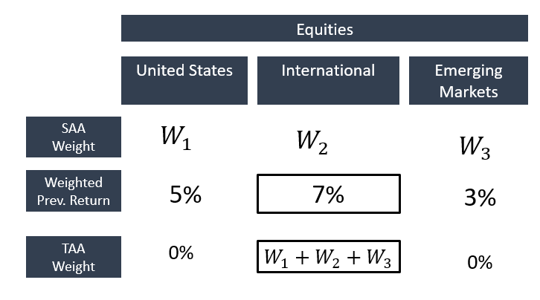

1. **Dual Momentum Results**

The results in this section are only for high risk portfolios with monthly rebalancing. The results for the other rebalancing frequencies and other SAA portfolios can be found in the appendix. The back-tests of the portfolios are run during an in sample period that runs from January 2007 to August 2015 and the out of sample period runs from September 2015 to July 2016.

* 1. **Individual In Sample Dual Momentum Results**



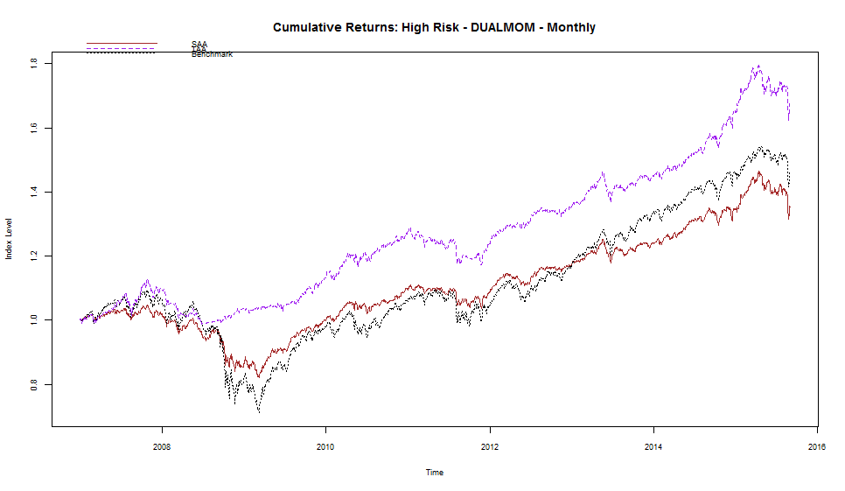

SAA

TAA

Benchmark

As a stand-alone signal, dual momentum does not seem to be adding much value to the overall tactical asset allocation objective to achieve acceptable returns while minimizing the effect of market crashes on the portfolio. While the relative momentum component improves the annual returns by over 1%, it also increases volatility by over 1% and does not improve the Sharpe ratio. While the individual dual momentum portfolio has higher skewness and less kurtosis than the individual time series momentum portfolio, it also has a higher maximum drawdown.

Despite these setbacks, the dual momentum signal does not significantly increase the risk of the portfolio and, as shown on the graph, still significantly outperforms the benchmark and strategic asset allocation portfolios.

* 1. **Impact of Dual Momentum on the Existing TAA Portfolio**

**5.2.1 In-Sample Results**



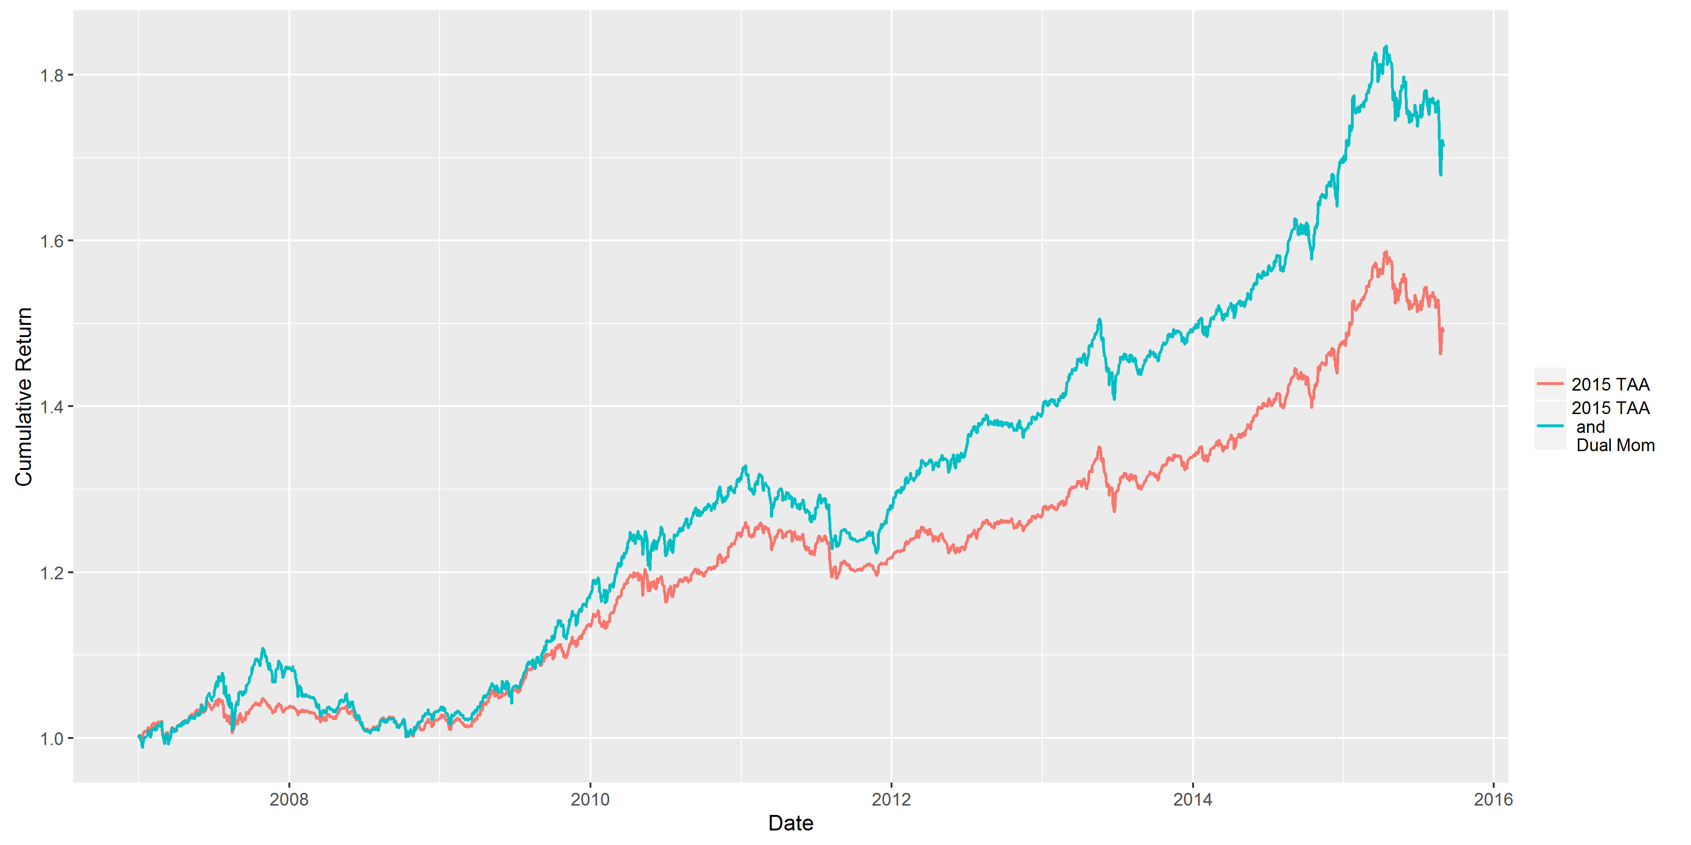

When added to the existing tactical asset allocation strategy, the dual momentum signal adds considerable value. The annual returns increase by almost 2% and while the volatility increases, the Sharpe ratio also increases by over 0.1. While the maximum drawdown is slightly higher with the dual momentum signal, the skewness is higher and the kurtosis is lower. As seen from the graph, the TAA portfolio with dual momentum outperforms the existing TAA portfolio.

Overall, the addition of the relative or cross-sectional momentum component appears to be improving performance on a risk adjusted basis and does not significantly increase the risk of the portfolio. One possible reason for the deviation in the performance of dual momentum on an individual and combined basis could be because the other signals in the existing tactical asset allocation strategy could be acting as a modulator to dual momentum and preventing it from taking extreme weights in certain assets at times when it is not optimal to do so.

**5.2.2 Out-of-Sample Results**



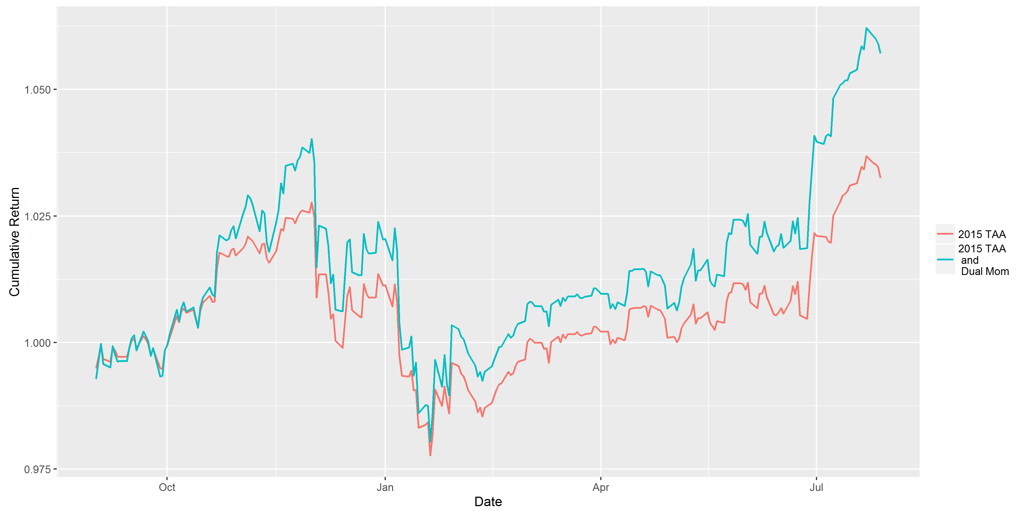

When looking at the results during the out-of-sample period (September 2015 to July 2016), the dual momentum signal appears to be adding significantly more value to the existing tactical asset allocation strategy relative to its in-sample performance. With the added signal, the annual returns almost double and the Sharpe ratio improves by more than 0.2. The maximum drawdown is less than 1% higher and, similar to all the other results, skewness increases and kurtosis decreases with the dual momentum signal. One potential reason that this signal could be adding more value in the out of sample period is because this period, overall was less volatile than the in sample period, which included the Great Recession.

* 1. **Summary of Dual Momentum Results**

The dual momentum signal adds value to the existing tactical asset allocation strategy. While it slightly increases the volatility and maximum drawdown of the existing TAA portfolio, it still significantly improves the risk adjusted returns of the portfolio and helps achieves HOD Group’s goal of meeting a certain return while avoiding market downturns.

**6 Variance Risk Premium (VRP)**

**6.1 Literature:**

Option implies volatility(IVol) is ordinarily higher than the realized volatility(RVol) for the SP500 Index, hence it is called Variance risk premium. This is the short run component of equity risk premium. Please refer to the plot between IVol and RVol. VRP leads the equity markets especially in during crisis, this has been reported in the Deutsche Bank Global Markets Research, September, 2011. VRP bottomed is October 2008 while equity markets bottomed in February 2009 and VRP rose up in February 2009 and equity markets recovered over the period March 2009 to April 2010. VRP is a contrarian indicator that measures overreaction and under reaction. When VRP is high, that implies IVol has risen to extreme levels and the market is in panic mode. Even though RVol is high, it’s not as much high as IVol. Market participants tend to move safer investments and equities or risky assets are undervalued. This is seen as a buying opportunity and similarly when VRP is low it is seen as selling opportunity. VRP is statistically significant in predicting up to 12-month ahead excess equity market returns.

 

Source: Deutsche Bank Global Markets Research, September, 2011

**6.1.1 How VRP is correlated with other asset classes?**

According to theDeutsche Bank Global Markets Research, September, 2011 paper VRP is positively correlated with equities, high yield bonds, commodities, gold and crude oil. It is negatively correlated with bonds.

**6.2 Proxy of VRP**:

Throughout the literature VRP has been used as equity market timing indicator. Empirical proxy for VRP is the difference between ex ante IV and ex-post RV. Implied Variance (IV) required to calculate VRP for U.S equities is CBOE VIX index. According to the Bollerslev 2016 paper, VRP of US equities can be used as a proxy for other asset classes as well. Based on the the study VRP global calculated as end of month market capitalization weighted average of VRP of eight countries. VRP global was found to be 89% correlated with VRP of SP500 and the average pairwise correlation between global and these countries is around 86%. Hence we concluded to use US equities VRP as proxy.

**6.3 Methodology:**

We will consider three methods to calculate VRP which were introduced in Deutsche Bank Global Markets Research, September, 2011, 2016 and the Bollerslev, Tauchen and Zhou 2009 papers. We have slightly modified method 2 and method 3.

**Method 1:** using historical realized variance. VRP at time t is difference of ex ante Implied and ex post realized variance.

$${VRP}_{t} ≡ {IV}_{t,t+1} - { RV}_{t-1,t}$$

**Method 2:** Slightly alternative of method 1, here we replace ex-post realized variance with conditional expectation of realized variance. By doing this we are separating the effects of temporal variation in volatility risk premium.

$${EVRP}_{t} ≡ {IV}_{t,t+1 } - E({RV}_{t+1})$$

A method to forecast realized variance was proposed in Deutsche Bank Global Markets Research, September, 2011 paper. RHS of the equation contains ex-post Implied Variance and ex-post realized variance.

${RV}_{t+1}$ = $α+ β.{IV}_{t-1,t}+ γ.{RV}_{t-1,t}+ ε_{t,t+1}$

**Method 3:** Reduced form HAR- RV model. This method was proposed in Bollerslev, Tauchen and Zhou 2009 paper. The difference is they have used ex-post intraday and weekly realized variances in addition to monthly. Since it requires daily RV, to implement this model we would require intraday data.

$${EVRP}_{t} ≡ {IV}_{t,t+1 } - E({RV}_{t+1})$$

$$E({RV}_{t+1})=β_{1}{RV}_{Daily}+β_{2}{RV}_{Weekly}+β_{3}{RV}_{Monthly}$$

**Implemented method:**

Since we do not have the data we modified the regression as a combination of method 2 and method 3. We perform rolling regressions using previous 3-month data and we have found this regression to have statistical significance.

$${EVRP}_{t} ≡ {IV}_{t,t+1 } -E({RV}_{t+1})$$

${RV}_{t+1}$ $≡$ $α+ β.{IV}_{t-1,t}+ γ.{RV}_{weekly}+ {γ.{RV}_{monthly} + ε}_{t,t+1}$

${RV}_{weekly}$ = $Σ_{weekly}{(sp500.returns)}^{2}$

${RV}_{monthly}$ = $Σ_{monthly}{(sp500.returns)}^{2}$

Now the next step is to calculate Z-score values and form trading rules based on that.

$${Zscore}_{t}={(VRP}_{t} -{VRP}_{63})/σ_{63}$$

**6.4 Trading Rules:**

When Z-score is less than -1 one should move away from risky assets and invest in cash. Here is an example trading rule on US equities. This rule is slightly different for corporate bonds because these are negatively correlated with VRP.



According to the literature it is recommended to increase weights in risky assets when VRP is high and move weights to cash when VRP is negative. But as per the instructions from the firm, VRP is triggered only if z-score is less than -1. This restriction on the upside potential of the VRP has its consequences which will be explained in the results sub-section.

**7 Variance Risk Premium Results**

The results in this section are only for high risk portfolios with monthly rebalancing. The results for the other rebalancing frequencies and other SAA portfolios can be found in the appendix. The back-tests of the portfolios are run during an in sample period that runs from January 2007 to August 2015 and the out of sample period runs from September 2015 to July 2016.

**7.1 Individual In Sample VRP Results ( TAA = SAA + VRP )**



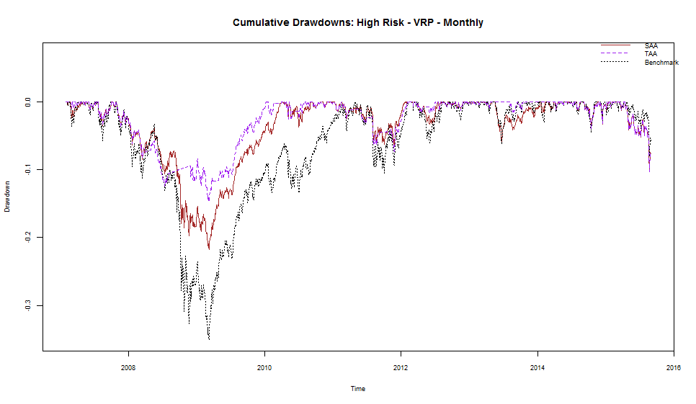

As a stand-alone signal, that is adding VRP as a overlay on SAA excluding 2015 TAA signals (AR, TSMOM, SMA). VRP has increased the risk adjusted returns, Sharpe ratio and maximum drawdown values are better than the benchmark. But the annual returns are less than the benchmark, on further analysis we found that this is due to limiting the upside potential of VRP signal. In-sample period covers 2008 recession, VRP helped in decreasing the large drawdowns but when the market recovered VRP signal is almost dormant limiting upside potential.

* 1. **Impact of VRP on the Existing TAA Portfolio along with dual momentum**



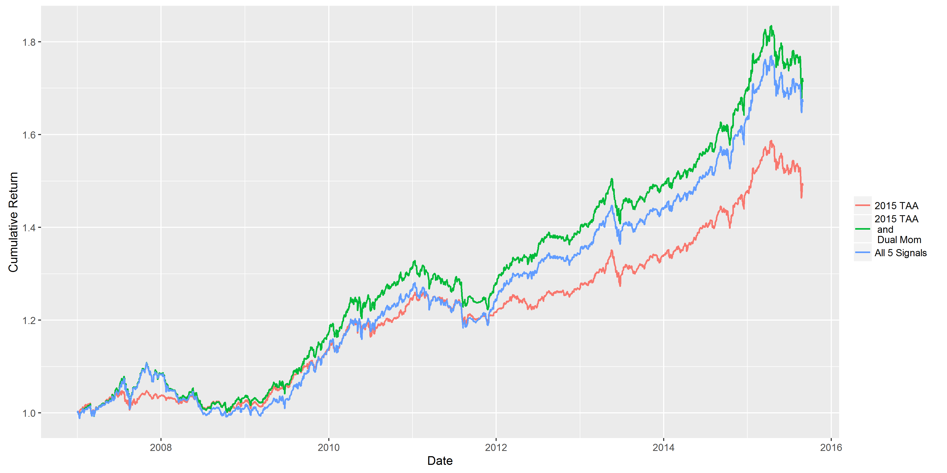

By adding the VRP signal to the portfolio2015 TAA and Dual Momentum, performance has slightly diminished. The reason could be that In-sample period has large drawdowns and it is highly volatile period

* 1. **Out of sample results**



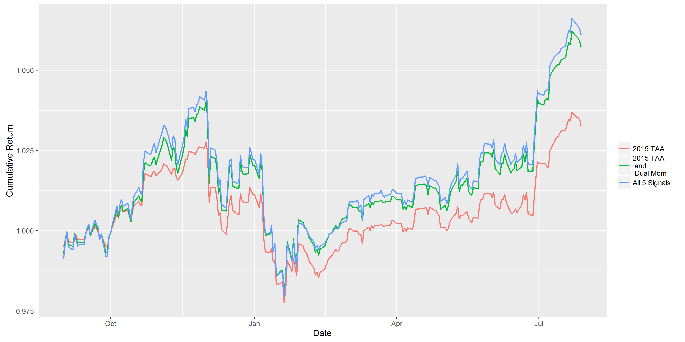

Out of sample results for the combined portfolio are almost the same compared to In-sample period results. Out of sample period is relatively low volatility period compared to out of sample period, hence VRP didn’t underperform the combined portfolio. In summary VRP is not adding much value to the TAA.

* 1. **Summary of Variance Risk Premium**

The VRP signal doesn’t add value to the existing TAA plus Dual momentum although it has individually performed well compared to SAA. VRP signal needs improvement in its prediction. The VRP regression can be further improved by adding macro-economic variables, technical indicators, term spreads etcetera. Refer to Deutsche Bank Global Markets Research, February, 2016 for more information on adding regression variables. By considering only extreme Z-score values -2 to +2 rather than -1 to +1 we may reduce the turnover and it might not affect the dual momentum performance. One more idea would be to lag VRP values by 3-months, as the literature says VRP prediction of returns peaks in 3-month.

**8 Conclusion**

Overall, the dual momentum signal adds value to the existing tactical asset allocation strategy but the variance risk premium does not. The overall reason for this is that the signals are highly correlated so there is very little additional impact that VRP can have to the other four signals. This explains why the VRP signal performs well on its own but not as part of the existing tactical asset allocation strategy.



Going forward, we suggest that the tactical asset allocation strategy should revolve around finding two to three signals that work the best, making those the main signals of your strategy and using other signals to modulate the main signals. The benefits of using signals to modulate other signals is illustrated in the next section.

**8.1 Application of Signal Modulation with the VIX**

According to the literature, relative momentum does not do well when the VIX is high during a recession. To utilize this effect to enhance the dual momentum signal, we calculated the 252 day rolling average and standard deviation of the VIX and used that to calculate the Z score. If the Z score was higher than one and the previous weighted excess return for US Equities (MSCI US Index) is negative, the dual momentum signal was turned off and time series momentum was used instead. Otherwise, the dual momentum signal continued to be used. The idea behind this was that if the VIX is high and the US is in a recession, the world is probably feeling the impact of it as well. When there is a recession it is also usually the case that the VIX is high and that the market has been underperforming recently. This modulator to dual momentum enabled the strategy to achieve higher returns, a higher Sharpe ratio, lower volatility and a lower maximum drawdown in the in sample period. While the modulator did not add much value out of sample, this is due to the fact that there was no recession going on during this period.

**8.2 Suggestions Moving Forward**

Instead of coming up with more contractionary timing signals to add to the existing tactical asset allocation strategy, we suggest that HOD Group instead investigates and implements ways to optimally implement the existing signals together and use the idea of modulators to improve the overall performance of the portfolio. In addition, the firm should also look at overweighting risky assets when they are predicted to do well in addition in addition to underweighting them when they are predicted to not do well and improve the implementation of the regression used to calculate the variance risk premium by adding macroeconomic variables to the regression.

1. **Appendix**
   1. **Dual Momentum Signal**
      1. **High Risk Monthly Results**
         1. **In-Sample**
         2. **Out of Sample**
      2. **High Risk Weekly Results**
         1. **In-Sample**
         2. **Out of Sample**
      3. **High Risk Daily Results**
         1. **In-Sample**
         2. **Out of Sample**
      4. **High Risk Turnover**
         1. **In-Sample**
         2. **Out-of-Sample**
      5. **Medium Risk Monthly Results**
         1. **In-Sample**
         2. **Out of Sample**
      6. **Medium Risk Weekly Results**
         1. **In-Sample**
         2. **Out of Sample**
      7. **Medium Risk Daily Results**
         1. **In-Sample**
         2. **Out of Sample**
      8. **Medium Risk Turnover**
         1. **In Sample**
2. **References**

Antonacci, G., 2011, “Optimal Momentum: A Global Cross Asset Approach”.

Antonacci, G., 2013a, “Absolute Momentum: a Simple Rule-Based Strategy and Universal Trend-Following Overlay”.

Antonacci, G., 2013b, “Risk Premia Harvesting Through Dual Momentum”.

Antonacci, G., 2015,”Dual, Relative and Absolute Momentum”, Dual Momentum Website. Bollerslev T., Tauchen G. and Zhou H., “Expected Stock Returns and Variance Risk Premia”, The Review of Financial Studies 22(11), 4463-4492, 2009.

Bollerslev, T., Marrone, J. and Xu, L., 2014, “Stock Return Predictability and Variance Risk Premia: Statistical Inference and International Evidence”, Journal of Financial and Quantitative Analysis 49(2), 633-661.

Bollerslev, T., Tauchen, G. and Zhou, H., 2009, “Expected Stock returns and Variance Risk Premia”, Journal of Financial and Quantitative Analysis 49(2), 633-661. The Review of Financial Studies (2009) 22 (11):4463-4492.

Deutsche Bank Global Markets Research, Quant Tactical Asset Allocation (QTAA), September, 2011.

Deutsche Bank Global Markets Research, The Quant View, February, 2016.

Chadwick, S., 2006, “Can the VIX Signal Market Direction?”, Credit Suisse Quantitative Trading and Derivatives Strategy.

Gray, W.R., 2015, “Avoiding the Big Drawdown: Is Downside Protection Helpful or Heresy”, http://blog.alphadirect.com/2015/08/13/avoiding-the-big-drawdown-is-downside-protection-helpful-or-heresy/.

Kozyra J. and Lento C., “Using VIX Data to Enhance Technical Trading Signals”.

Kritzman M., Li Y., Page S., and Rigobon R., Principal Components as a Measure of Systematic Risk, 2010.

Luo Y., Cahan R., Alvarez, M., Jussa J. and Chen Z., September 19, 2011, “Variance Risk Premium as a Market Timing Factor”, Deutche Bank Global Markets Research, 6-12.

Orford J., June 15, 2015, “The Case for a Steady Volatility-State Managed Portfolio”, http://econpicdata.blogspot.it/2015/06/the-case-for-volatility-managed.html.

Whaley, R.E., 2008, “Understanding VIX”, http://ssrn.com/abstract=1296743.

Yang, D. and Zhang, Q., 2000, “Drift Independent Volatility Estimation Based on High, Low, Open and Close Prices”, Journal of Business